Chapter 11
Modern Computer Systems

11.1 (BL1+) The ads submitted by students will each be a bit different, so solutions to this exercise will vary. The solution below uses the ad from Chapter 1 as an example of a typical solution.
2 GB SDRAM
Core 2 Duo Processor
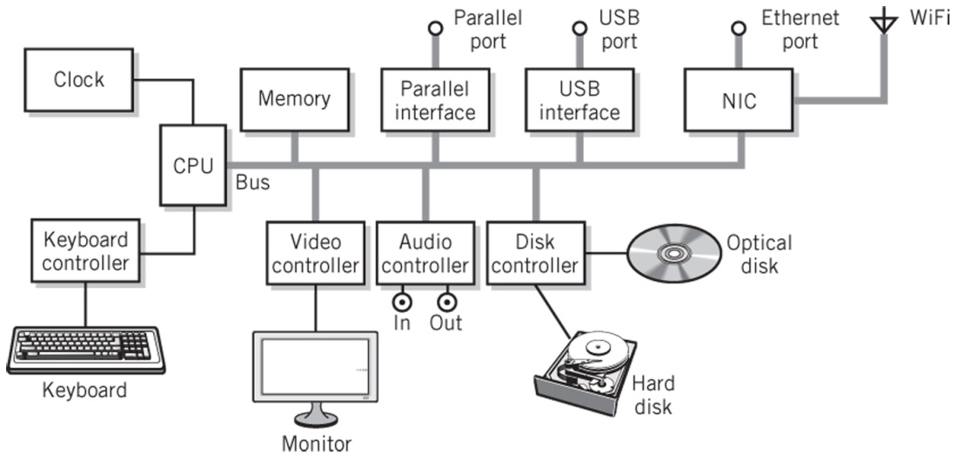

802.11n
PCI Express
DVD Drive

160 GB Hard Drive
SATA
Graphics Card
20” flat panel display

11.2 (BL2) Each bus can be optimized to meet its own requirements. For example, external buses, such as USB, are optimized for connection to multiple external devices at low cost with relatively high speed; SATA buses are optimized specifically for disk drives; internal buses, PCI and PCI Express are optimized for high speed interconnections to the CPU. Some buses are maintained for legacy purposes. For example, many desktop computer plug-in cards are designed to fit PCI sockets.
11.3 (BL2-) The purpose of a bus interface is to convert the format of one bus to that of another, so that the buses can communicate transparently, without loss of data. The bus interface allows buses with different characteristics to work together, allowing each part of the system to be optimized separately, with its own bus structure.

11.4 (BL3) The data in nearly every situation is ultimately processed and stored in multiple bits. For example, registers typically process data in 32- or 64-bit chunks. Memory is stored in 8-bit bytes. Data is moved from one register to another in parallel. Furthermore, in theory at least, it should be faster to move data from one point to another, since there are multiple lines carrying the data. The use of a serial bus to move data from one point to another, thus, usually requires conversion from parallel to serial as it enters the bus, and conversion back to parallel from serial at the destination.

Although parallel buses are useful for extremely short runs, such as those within an integrated circuit, in practice, they are not useful for longer runs. At the high clock speeds of modern computers, electromagnetic interference (or radio waves) between the closely-placed lines in a parallel bus create noise that can ultimately overwhelm the signals on the bus, making accurate detection at the destination difficult; A condition known as skew is also a problem. Skew occurs when the data rate is sufficiently high that the slightly different times at which data on adjoining lines arrives can make it unclear which bit corresponds to a particular clock cycle, creating potential data errors. This difference in arrival time results from slightly different delays in the circuits generating the data on each line.

Parallel buses on the backplane of a motherboard consume valuable space, or "real estate", making it more difficult to reduce the size of the motherboards to meet the requirements of modern laptops and other small computer systems. External parallel buses, such as those used to connect the printer to a parallel port on older desktop computers require a large connector at the port. The parallel cable itself is large, awkward, and expensive. The length of the parallel cable, and its use outside the computer case, makes it difficult to avoid noise and adjacent-line radio interference. The cost of external buses is necessarily high.

There are some situations when it is not even possible, much less practical, to offer parallel bus transport as an option. Data stored on a disk is read and written serially to the rotating disk device, using a single head. The parallel bus that connected older disks to their controllers, known as IDE or PATA, had to be converted to serial form within the disk drive. Data on a network is inherently serial, due to the media used for the transport of data through a network.

11.5 (BL2) The data rate of the video connection in bytes/second is 1920 x 1080 pixels x 3 bytes/pixel x 60 frames/second = 373 MB/second. One PCI-Express lane can handle this data rate.

11.6 (BL3) Skew is defined as the slight difference in time that data signals on different lines in a parallel bus arrive at the destination point. At high clock rates, data on some lines may change before the data on delayed lines arrives at the destination, causing errors when the data is read. Skew errors cannot occur on serial buses, since the data is read one bit at a time, one bit after the other, so any delay at the destination is irrelevant. Even in the case of a multilane bus, such as PCI-Express, skew is not relevant, because each lane is serial and independent, each carrying its own bytes or words of data serially.

11.7 (BL1+) 10 Gb/second = 1.25 GB/second. Each PCI-Express lane can carry 500 MB/second, or 4 Gb/second. Therefore, three lanes are required to carry 10 Gb Ethernet traffic.

11.8 (BL3) Here are the primary features and characteristics of the various buses listed in the exercise. All of the buses are serial:

PCI-Express: a full-duplex multilane bus; used as a system bus, primarily to connect high-speed devices, such as graphics controllers, to the CPU and memory. Is gradually replacing the signal-equivalent parallel PCI bus. May be used internally or ported as an external bus through a connector. Each lane in the current specification can carry full-duplex data st 4 Gigabits/second in each direction.

SATA: a full-duplex, single lane bus that is primarily designed to interconnect with system buses to secondary storage devices such as hard disk. SATA has essentially replaced the signal-equivalent parallel ATA (previously known as IDE) bus. Although SATA is primarily intended for internal use, a compatible eSATA bus can be used to connect external disk drives to a computer system. SATA currently operates at speeds of 1.5-6 Gigabits/second.

USB (Universal Serial Bus): the current primary external bus for connecting peripheral devices to a computer. (See text, pp. 354-355 for discussion of its topology.). A Single lane bus, with hubs that extend the bus into a tree structure that supports up to five tier levels containing as many as 127 devices. USB2 is the most common specification, USB2 operates at 480 Gigabits/second. USB3 is a recent development, with devices first expected to appear in 2010. USB3 is specified at 5 Gigabits/second. Unlike earlier versions, which are half-duplex, USB3 is specified for full duplex operation.

FireWire (also known as IEEE 1394): Intended as an external bus for connecting external peripheral devices to a computer. (See text, pp. 355-356 for discussion of its topology.) FireWire supports up to 63 devices in a tree structure; however, unlike USB, which requires a single host controller, FireWire supports multiple hosts and allows direct device-to-device communication. The original FireWire specification upported 400 Megabit/second half-duplex speeds. Current specifications allow 3.2 Gigabit/second full-duplex communication, however support for FireWire appears to be fading in favor of USB, despite FireWire's flexibility.

Serial Attached SCSI (SAS): SAS is a signal-equivalent serial version of SCSI. SCSI is a parallel multidrop bus used mostly in high-end computer system for inteconnecting secondary storage devices to computers. The original SCSI bus was a more expensive, better performance alternative to the IDE bus. (See text, pp. 356-357 for a brief discussion of SCSI). SAS can support up to 16,384 devices at speeds up to 6 Gigabits/second. It is also possible to connect SATA devices drectly to a SAS bus, though the converse is not true.

11.9 (BL2) A bus architecture uses CPU instructions to initiate data transfers between I/O and memory, and the I/O request is executed by a program. Generally a software interrupt or service request instruction is used to initiate the program that makes the request. The bus that connects the I/O device to memory is frequently shared by the CPU-memory connection as well.

The channel architecture provides a separate channel processor for processing I/O. An I/O request is initiated by the CPU with a single START SUBCHANNEL call to the I/O processor. After that, the CPU is free to perform other processing. A single request can even order the channel processor to transfer multiple, noncontiguous blocks. Furthermore, the channel subsystem has its own independent pathway to memory, so that CPU-memory transfers do not slow down the transfer. (Noting, of course, that memory itself must still be managed to prevent conflicts.) The channel subsystem also provides a separate path to each device control unit, so that it can control several transfers simultaneously.

The channel architecture is more powerful and flexible, because it isolates and processes each operation independently, whereas the CPU handles the processing in a bus architecture. Nonetheless, the basic I/O operation is identical. Initiate a request using a control program stored in memory, then provide a DMA transfer between the device in memory. In both cases, too, an interrupt is returned to the CPU to indicate the completion of the transfer.

11.10 (BL2) The three primary conditions for DMA are:

- a means to connect the I/O interface with memory
- I/O modules capable of reading and writing to memory
- the means to avoid conflicts between the CPU and I/O modules during transfers in the channel architecture:
- the channel subsystem has its own direct connection with memory
- the channel subsystem has a processor which can read and write to memory
- conflicts are avoided, since the channel subsystem has its own path to memory, separate from the CPU-memory path. However, the system must still be designed to avoid conflicts at the memory interface itself.

11.11 (BL2) A cluster can be used to provide fault-tolerant computing by duplicating processing in multiple systems in the cluster. The systems in the cluster can even be placed at multiple locations by networking the links, providing protection against disasters such as network outages or power failures in a particular location. Multiple links provide protection against failure in the links themselves. As with the symmetric multiprocessor, the results can be compared for accuracy. Failures and errors in a single computer can be disregarded, and processing continued on other machines. Normally, data would also be stored multiply, and compared for consistency periodically. The cluster has one additional advantage over the multiprocessor for this purpose. Since the multiprocessor system is dependent on failures in common areas, such as bus failures, memory failures, and the like, the cluster system is inherently more fault tolerant, since each system in the cluster is independent.

11,12 (BL2) A cluster architecture that provides easily accessible links can provide rapid scalability simply by adding new node systems to the cluster. Ethernet-interconnected clusters are particularly flexible in this respect, since scalability can be achieved simply by plugging additional computer systems into the network and setting up the software to include the additional system or systems.

11.13 (BL3) (BL2+) Windows Server, Linux, and IBM zSeries system all provide support for clustering. IBM hardware provides support for extensive load and resource sharing, with message links extending down to the cache memory level, support only minimally available on most Intel platforms. Indeed, modern IBM zSeries Systems include clustering as a part of the basic system configuration. Linux provides various forms of clustering support in the kernel of the operating system. Additional specialty packages offer additional clustering options. Many modern supercomputers are built from Linux-based clusters. Although Windows was a latecomer to the clustering circle, Windows Computer Cluster Server 2003 and 2008 provide the support required for both high performance and failover clustering.

11.14 (BL2) Clustering provides the ability to increase the overall power of a computer system by sharing the computer load and resources between multiple systems. In particular, the shared-disk model allows multiple systems access to the same data, with individual computer service requests provided by any system with available time and resources. This allows load-balancing, as well as increased availability and overall computer power. In addition, clustering provides failover protection and improved uptime, since the services provided by a system that is down for maintenance, upgrade, or failure can simply be switched to another system in the cluster.

11.15 (BL2) Traditional clusters rely on high-speed messaging links to pass messages and information between the various computers in the cluster. Beowulf clusters use a dedicated Ethernet for this purpose.

11.16 (BL2) Clusters operate primarily to extend the capabilities of a single machine, for the purposes of high availability and fault tolerance, high performance, and scalability. As such, the computers in a cluster work collaboratively, often on a single application or group of applications. The computers in networks operate essentially independently, providing services to other computers in the network, but not consistently in an intentionally collaborative fashion, as is the case with clustered computers.

11.17 (BL2+) This is an individual project exercise. A recent list and description of current grid projects can be found at http://en.wikipedia.org/wiki/List_of_distributed_computing_projects.

11.18 (BL2+) Cloud computing is based on the concept of computing processing power and storage as a resource, available on the Web as a service. Services include Web-based software applications for performing a variety of tasks, plus large-scale storage capabilities. Both grid computing and cloud computing rely on the availability of computing power as a resource. However, grid computing is more specialized, using distributed computing power to work on a particular large-scale program application, whereas cloud computing is intended for more general use, providing a wide variety of services. The implementation of a cloud may be distributed, like a grid, or may be more centralized.

